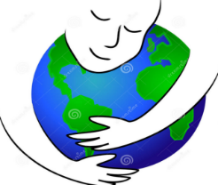
Natural Resources &
the Water Cycle Study Guide
- Label the following first as Renewable (R) or Nonrenewable (N) Resources and then if Renewable, Limited (L) or Unlimited (U):
  - ____ Solar Energy
  - ____ Coal
  - ____ Forest of trees
  - ____ Fossil Fuels
  - ____ Natural Gas
  - ____ Fresh Water
  - ____ A single tree
  - ____Wind

- Label the following as Energy (E) or Material (M) Resources:

  - _____Wood glass
  - _____Solar Power
  - _____Wind
  - _____Glass
  - _____Metals
  - _____Hydropower
  - _____Plastics
  - _____Geothermal energy

- List the 7 events of the water cycle as discussed in class:

- ________________ Land drains precipitation
- ________________ Liquid water turns to gas.
- ________________ Rain, snow, sleet, hail
- ________________ Water vapor turns back into droplets
- ________________ Gas changes to a liquid forming water droplets
- ________________ Snow and ice turn directly into water vapor
- ________________ Area where precipitation pools such as streams, rivers, and lakes.
Sketch the Water Cycle (use colored pencils):

Human Impact on the Environment
- What percentage of the Earth’s water is salt water?
- Why is NonPoint-Source Pollution more difficult to control than Point Source Pollution?

- Label the following types of pollution as: Thermal (T), Chemical (C), or Biological (B)
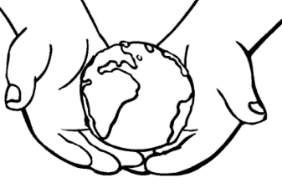
  - ____ Pesticides used in Agriculture
  - ____ Wastewater from showers and toilets
  - ____ Water used by power plants for cooling
  - ____ Sulfur in exhausts leading to Acid Rain
  - ____ Animal waste from runoff
- _____________________ causes fast growth of algae in lakes leading to decrease oxygen supply.
- Humans can cause different types of environmental pollution. When household cleaners are dumped down the drain and make their way into the water supply, which type of pollution has taken place?
  - Air pollution
  - Thermal pollution
  - Chemical pollution
  - Biological pollution
- Humans need fresh, clean water to survive. Which of these statements is TRUE about fresh water?
  - An unlimited amount of freshwater is available on Earth.
  - In many places on Earth, freshwater is being used up faster than it can be replaced.
  - The global population is currently decreasing, and people are using less freshwater
  - Freshwater is considered an inexhaustible resource.
- List the 3 greenhouse gases:

- What is ozone and where is it found?

- Explain the difference between weather and climate?

- List the 3 factors that affect climate.

- There are many sources of air pollution in the United States and around the world. Some are natural sources, and others come from humans. Which of these examples is a natural source of air pollution?
        - Car exhaoust fumes
        - Methane from cow manure
        - Fertilizers from crops
        - Smoke from burning fossil fuels

